1.

(a) All full-time female graduate students at the university. (b) The 67 students that returned the survey. (c) The proportion of all female students at the university that have a job outside the university. (d) The proportion in the sample ( 19 67 ). (e) No, it’s a survey (a type of observational study) (f) Possibly, but there could be all sorts of bias introduced. Students who work may very well be more or less likely to send in their survey than those who do not.

2.

(a) False. The standard deviation can be greater or less than the median—they are measuring completely different things. (b) False. The variance is usually greater than the standard deviation, but not if 0 ≤ s 2 ≤ 1. (c) False. The mean can be greater or less than the standard deviation—they are measuring completely different things. Balka ISE 1.09 3.6. CHAPTER EXERCISES 20 (d) True. The standard deviation is a little greater than the average distance from the mean, which has a maximum of 1 in this case. The standard deviation of the sample (0, 2) for example, is s = 1.414214. (e) True. The median is usually less than Q3, but they can be equal if there are repeated values in the data set. For example, if the data set is 0, 0, 0, 0, 0, 0, 0, 0, 0, 0, 0, 0, 12, 24, then the median and Q3 will both equal 0.

3.

(a) The distribution is slightly skewed to the left. (b) The 90th percentile would be a little less than 60 kgf. (c) There is no legitimate way to estimate this quantity from the given data. If we were to start playing guessing games, we could guess that the 90th percentile for adult Germans would likely be less than the 90th percentile of this data set (since the sample was made up of males of university age). (d) Both the mean and median would be reasonable measures of central tendency here. It would be perfectly fine to report either or both. (e) From the boxplot, the median looks to be approximately 52.5. Since the distribution has slight left skewness, the mean is likely slightly less than this quantity. (Based on the raw data used to create these plots: Median = 52.25 and x¯ = 50.91.)

(f) While the distribution shows slight left skewness, it is roughly mound-shaped, so the empirical rule provides a bit of guidance. The standard deviation likely falls in or close to the interval Range 6 to Range 4 . The range is somewhere between 30 and 35 kgf, so let’s estimate the range to be 33. The standard deviation is likely in or near the interval 33 6 = 5.5 to 33 4 = 8.25. (Based on the raw data used to create these plots: s = 7.74.)

4.

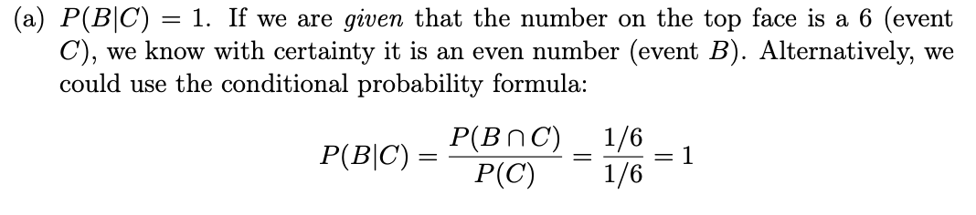

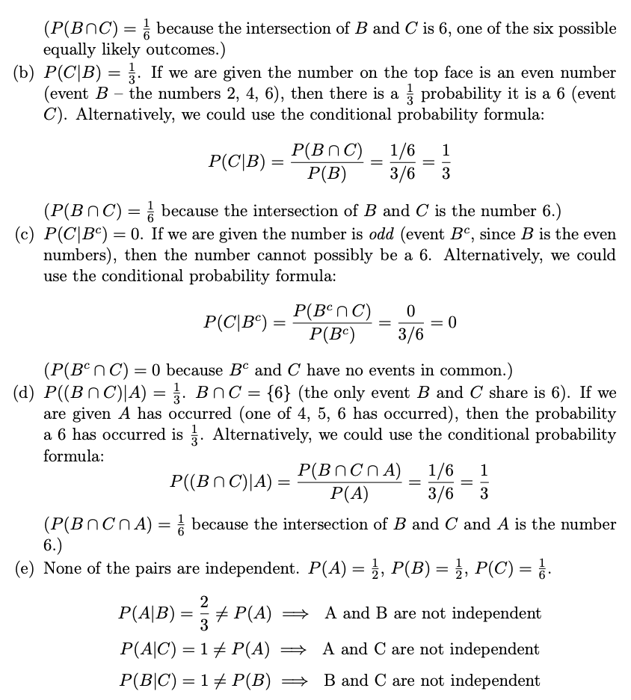

5.

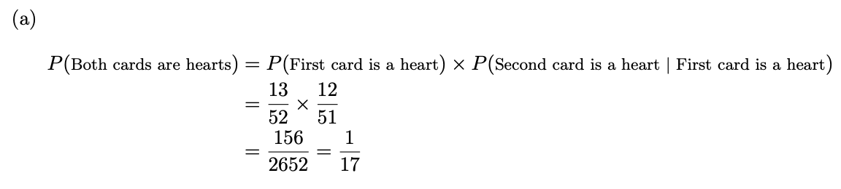

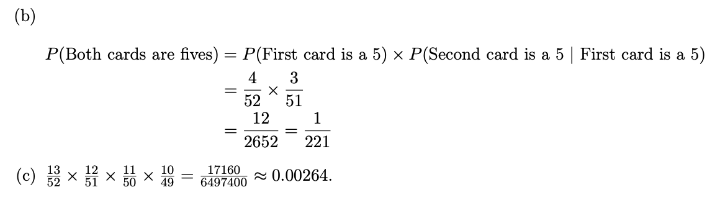

6.

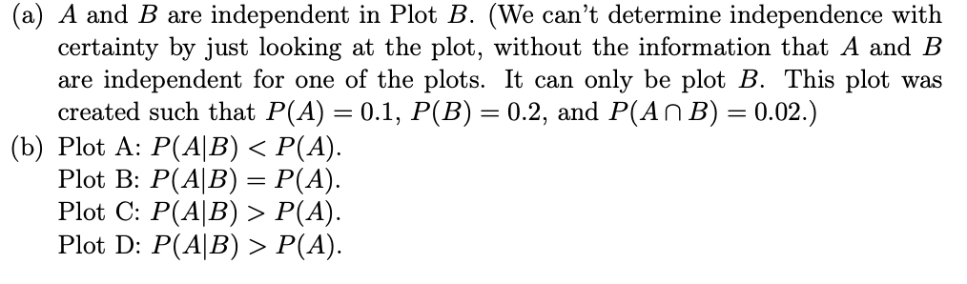

7.

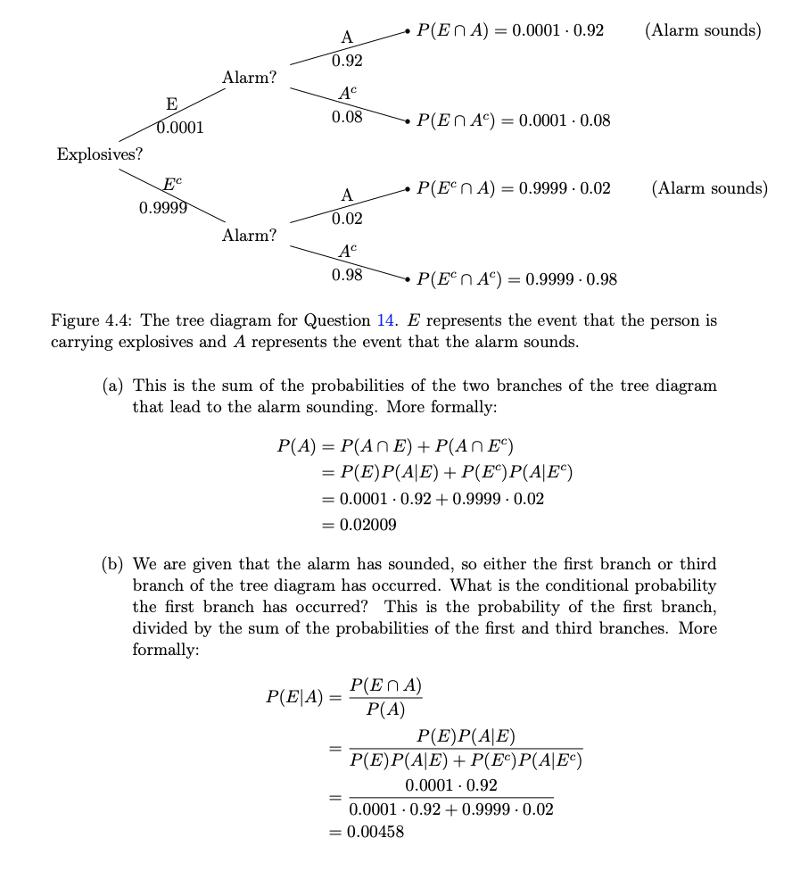

8.

A is correct, and the rest of the statements are false. The p-value is the probability, given the null hypothesis is true, of obtaining a test statistic with at least as much evidence against the null hypothesis as what was observed in the sample.

9.

